BRAND IDENTITY

THE PROBLEM:
- Most logistics = blue equipment/blue and black themes and colours.
standard yellow high vis – same as everyone else.
(safe, corporate, boring, no brand recognition or image)
- Event organisers = pink or standard high vis yellows
- Riggers/stand build companies = Orange / red
- Everything blends together. No one stands out. No identity (apart from logo / text on back)
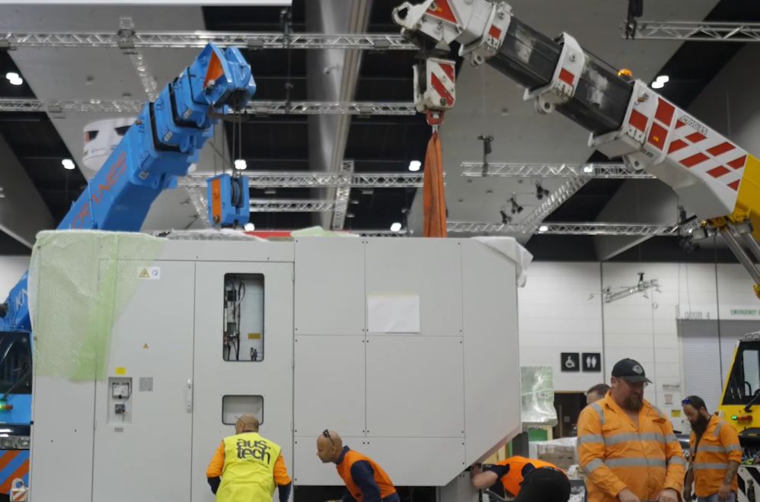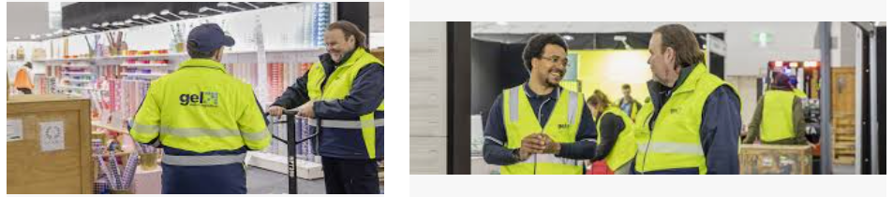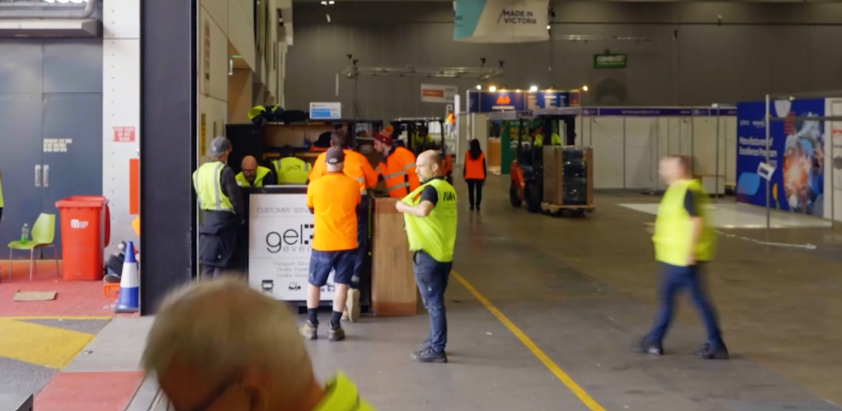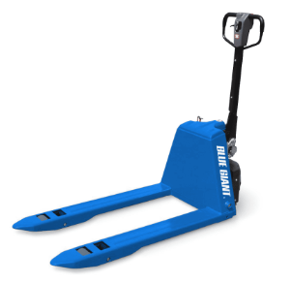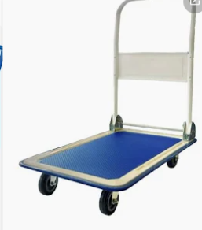
THE OPPORTUNITY:
Green is fresh, visible, different.
- Easy to spot on a crowded show floor
- Memorable (clients remember "the green team")
- Professional but not corporate
- Eco-friendly vibe (even if not the focus)

ON THE WEBSITE:
- Green buttons (not everywhere, just key actions)
- Green highlights on icons
- Green borders or accents
- NOT green backgrounds (keep it clean, white or black main, whatever the standard formula is)
- Green logo (maybe) - Green highlight..?

IN REAL LIFE :
- Green pallet jacks
- Green trolleys
- Green high-vis vests
- Green stickers on equipment
- Green-branded tape

THE MESSAGE:
When a client looks across the loading dock/show floor and sees green, they know:
- That's my team
- That's professional
- That's different
------------------------------------
Maybe two greens? Maybe all bright? A deeper one for web (clean/professional), a brighter one for onsite gear (visibility). Open to suggestions."
IMAGES BELOW

